THEORY QUESTIONS
1.
a)

The diagram below are illustrations of two cells labelled A and B
Study the diagram carefully and answer the questions that follow.
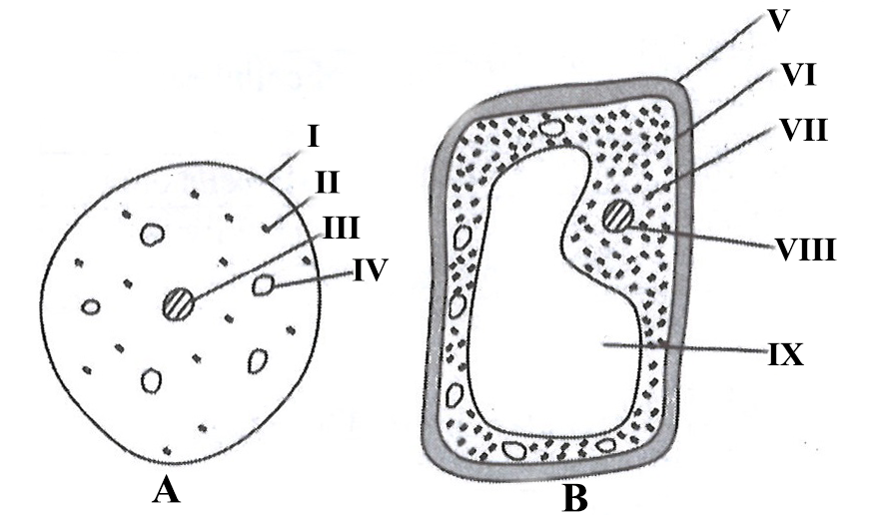
i)

Name each of the parts labelled I, II, III and IV.
ii)

Which of the parts named in (a)(i) is the same as the parts labelled VI and IX in cell B?
iii)

Which of the cells is a plant cell?
iv)

Give two reasons for the answer given in (a)(iii).
v)

Tabulate two differences between the parts labelled I and V.
b)

The diagram below is an illustration of an experiment carried out in the laboratory.
Study the diagram carefully and answer the questions that follow.
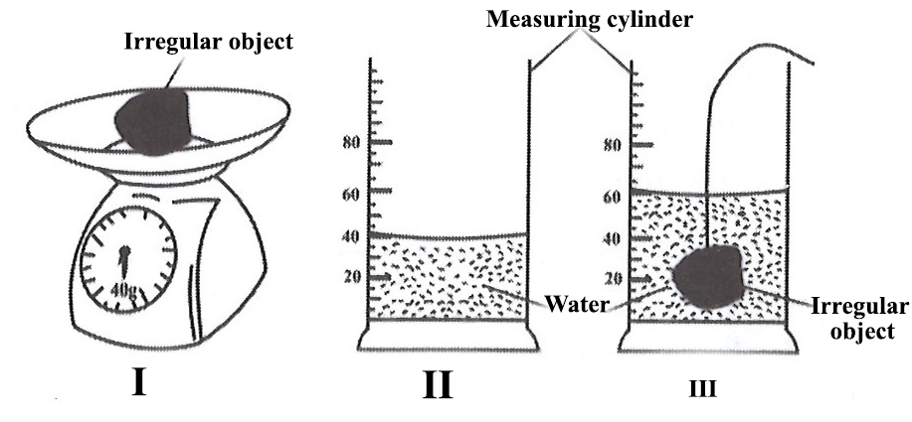
i)

Read and record the:
(α) mass of irregular object (M) in I
(β) Volume of water (V₁) in II
(γ) Volume of water (V₂) in III
ii)

Determine the volume of the irregular object.
iii)

Calculate the density of the irregular object.
iv)

Name the instrument that could be used to measure the mass of an irregular object.
v)

State one precaution to be taken in performing the experiment.
c)

The following activities were performed in the laboratory by groups of pupils.
Study the activities and answer the questions that follow.
i) Camphor was heated.
ii) Wood was burnt.
iii) Iron nails were heated strongly.
iv) Sodium chloride was dissolved in water.
i)

Which of the following activities are:
(α) chemical processes;
(β) physical processes.
ii)

Give two reasons why the activities listed in:
(α) (i)(α) are chemical processes;
(β) (i)(β) are physical processes.
iii)

Give two examples of physical change that take place in your environment.
d)

A farmer cultivated soya bean, yam and maize on a farm in a rotational programme as illustrated below.
Study the diagram carefully and answer the questions that follow.
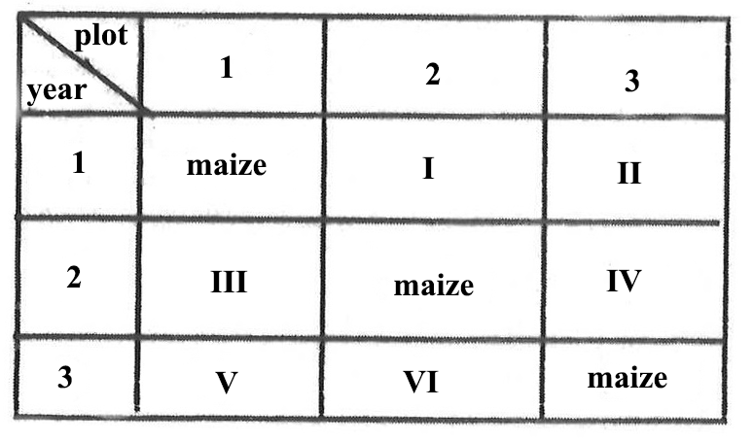
i)

Copy and complete the table.
ii)

List three principles to consider when planning this rotational programme.
iii)

Give two reasons for selecting the crop named for V in plot 1 year 3.
iv)

State one advantage of practising this farming system.

2.
a)

State three external features of the weaver birds that adapt to live successfully in its environment.
b)

List four harmful effects of air pollution.
c)

i)

Draw the magnetic lines of force around a bar magnet.
ii)

If the work input of a machine is 30 joules, what would be its efficiency when the work output is 25 joules?
d)

Outline three principles involved in vegetable crop production.

3.
a)

i)

State two differences between an ecosystem and a habitat.
ii)

What is meant by the term blood?
b)

Explain why it is difficult to separate iron and sulphur mixture after strong heating.
c)

Draw and label a diagram of a ray of light which makes an angle of 35⁰ with the surface of a plane mirror.
d)

State two
i)

advantages of a land rotation.
ii)

disadvantages of land rotation.

4.
a)

State one symptoms each of the following infections diseases:
i)

cerebrospinal meningitis;
ii)

chicken pox;
iii)

typhoid.
b)

i)

What is energy?
ii)

Give two reasons why it is necessary to conserve energy.
c)

i)

State two methods of restoring soil resources.
ii)

Explain briefly one of the methods stated in (c)(i).
d)

i)

What is binary compound?
ii)

Write the chemical formula of the compound formed between:
(α) Oxygen and lithium
(β) Magnesium and Chlorine
iii)

Name the compound formed in (ii)(α)

5.
a)

i)

State two uses of water in agriculture.
ii)

Name two crops that are deep rooted.
b)

i)

Explain the term circulatory system in humans.
ii)

Classify each of the following processes as diffusion or osmosis:
α)

absorption of water by the roots of a plant
β)

movement of digested food from the small intestine into the blood stream
c)

i)

What is mass?
ii)

A box of equal size 3cm has a density of 2.0gcm⁻³.What is its mass?
d)

Give the state of each of the following substances:
i)

ash;
ii)

carbon dioxide.

6.
a)

State three functions of the female reproductive system in humans
b)

i)

What is the role of a capacitor in a circuit.
ii)

Give two examples of a compound machine
c)

i)

What is Integrated Pest Management?
ii)

State two advantages of practicing integrated pest management.
d)

i)

State two classes of mixtures.
ii)

Classify each of the following substances under the classes stated in (i)
(α) bronze;
(β) when perfume is sprayed into the air.

